Wei Liang

The only Wei to pass

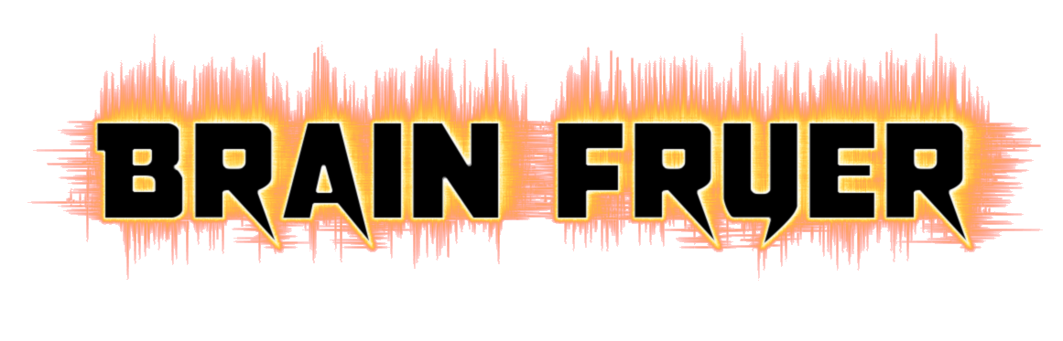

**Rocka’ Paper Scissors Refined**

Settling it like adults

Contents

Game Pitch 1

Objective 2

Characters 3

Controls 4

Keyboard 4

Game Flow 5

Level Breakdown 5

Features 5

Difficulty Adjustment 5

Score 5

User Interface 6

Menu 6

Game Play 7

EASY MODE 7

Normal 8

Hard Mode 9

Hell Mode 10

Nightmare 10

# Game Pitch

If you've ever needed help shouldering the sky or making a small decision like who gets the last piece of pizza or who gets to ride shotgun, you're probably more than familiar with the game of rock, paper, scissors… And your properly not very good at complying to the rules after your devastating defeat.

You suck at Rock Paper Scissors!? Do you have a screw loose? Don’t worry, inside is a built-in screwdriver.

This game will teach you to wear the shoes of others,

so that others have no shoes to wear!

Walk on others’ paths,

so that they have no paths to walk!

# Objective

The objective of the game is to increase one’s instructive-inborn-reaction-speed when it comes to rock paper scissors judgement. To do that, the element of endless incoming rounds of rock paper scissors are implemented.

# Characters

|  |  |
| --- | --- |
|  | **Name:** Rock (Alias: Fist)  **Age:** 0  **Gender:** Object  **Race:** solid mineral  **Origin:** Earth  **Weapon Type:** Melee  **Strength:** Can destroy steel like objects  **Weakness:** Has a fear of being dumpling fillings  **Personality:** Straight Forward, Solid Reliability  **Bio**: Just surfaced from earth’s tummy. I make everyone feel safe and gives them a strong foundation. I am strong, solid, and unchanging. |
|  | **Name:** Paper (Alias: Slap)  **Age:** 5  **Gender:** Determined when summon  **Race:** The Armed Race  **Origin:** Human Body  **Weapon Type:** Slapper  **Strength:** Can deflect objects, wrap objects  **Weakness:** Has nightmares of holes appearing on it’s body  **Personality:** Flexible, Blank, Fast Learner  **Bio:**  At the age of 5, we are summoned by God to fuse with human bodies. We are a deadly weapon known to mankind. We are mainly summoned onto those creatures with longer hair. We break fights, we break relationships! |
|  | **Name:** Scissor (Alias: Peace)  **Age:** 2  **Gender:** Tool  **Race:** Craftsmen  **Origin:** Hephaestus’ the God of Tools collection.  **Weapon Type:** Slicer  **Strength:** Can cause severe slice marks, pierce holes  **Weakness:** Fears being bent, hate being dull  **Personality:** Sharp witted, Competitive  **Bio:** Born from the intense heat of blacksmithing, I have traveled far and wide and have been referred to by many names. Peace is my most renounced legacy. |

# Controls

## Keyboard

The following keys projects the corresponding Hand

|  |  |  |
| --- | --- | --- |
|  |  |  |
|  |  |  |

The Arrow Keys can rotate the player to the direction they wish to shoot.

|  |  |  |  |
| --- | --- | --- | --- |
|  |  |  |  |
|  |  |  |  |

# Game Flow

The game flow consist of the **Main Menu** where players can select their desired level of difficulty Then proceed **with playing the level**, after if they happen to lose, they will be sent to the **Game Over screen.**

Menu > Level > Game Over > Menu

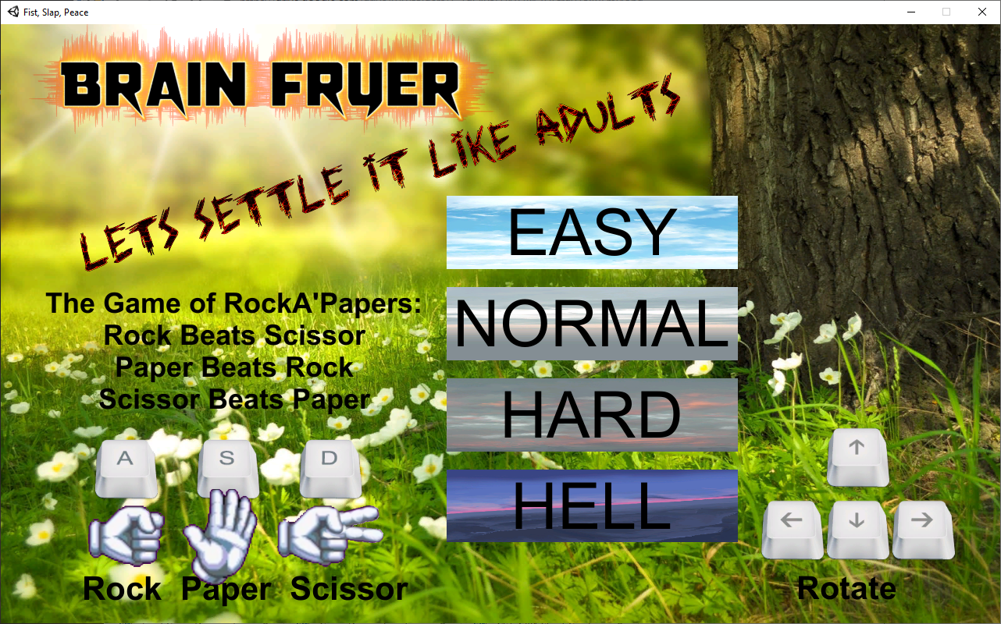 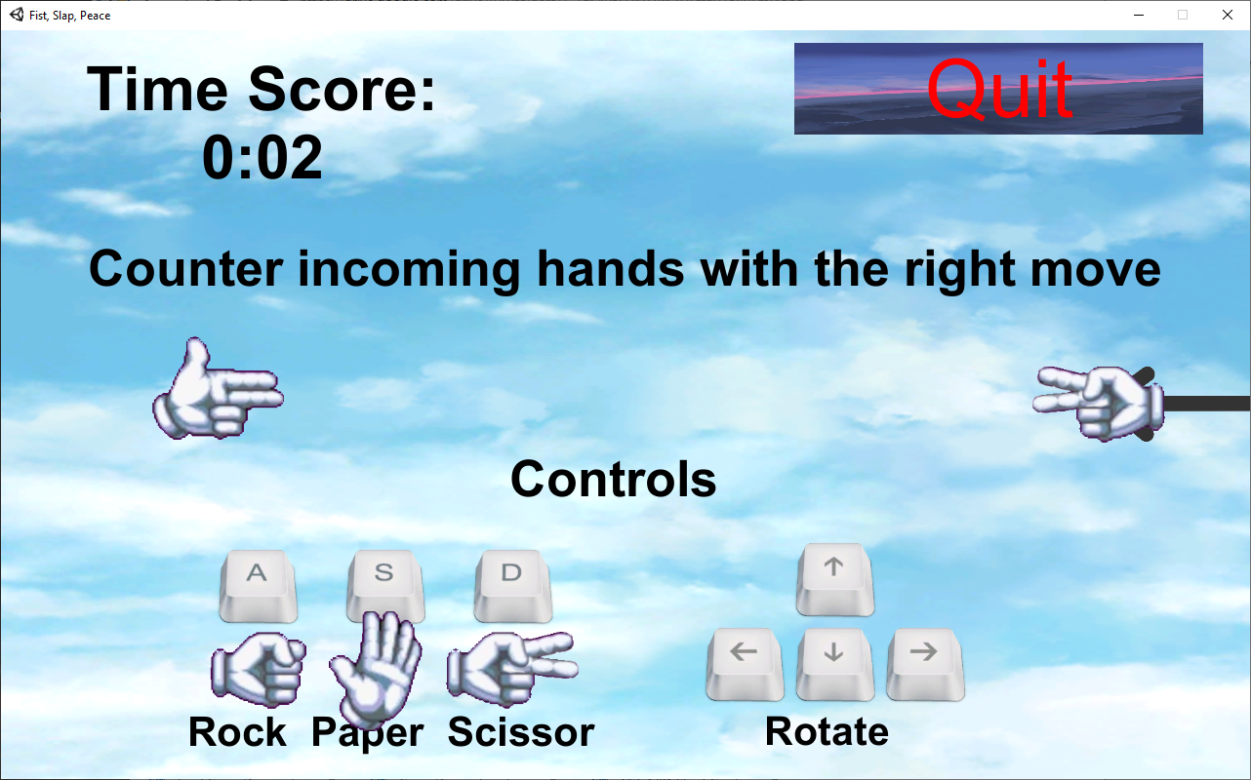 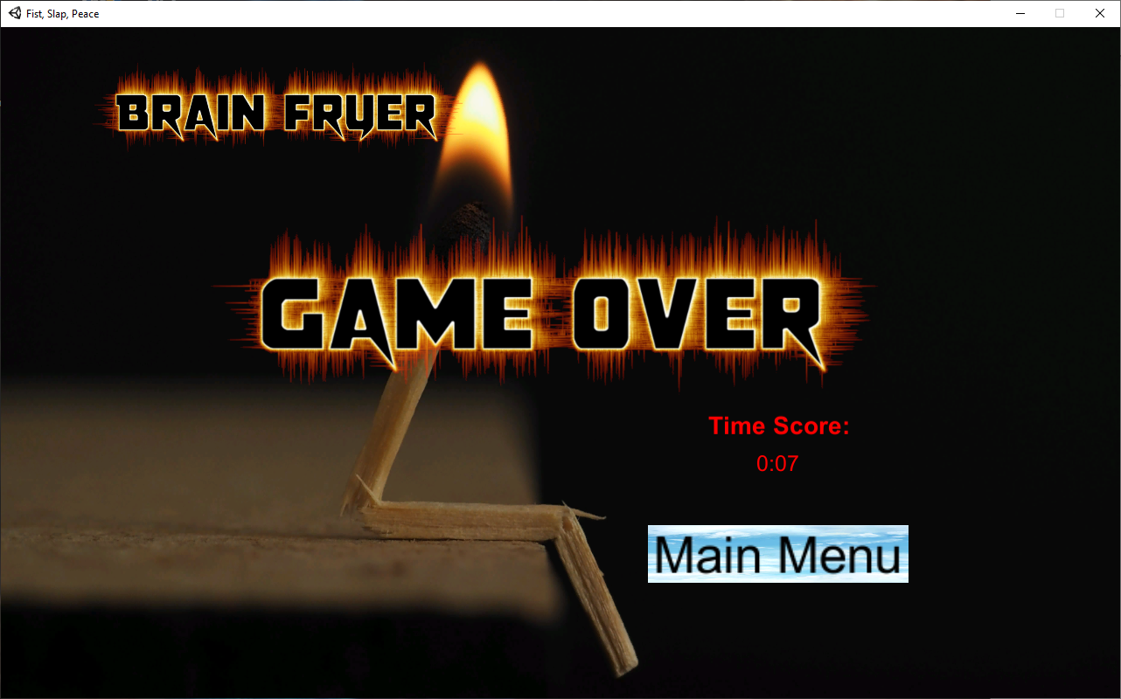

# Level Breakdown

|  |  |
| --- | --- |
| Modes |  |
| Easy | Level where incoming hands only come from the RIGHT, at a very slow paste, meant to help players get use to the controls. |
| Normal | Incoming hands come from 2 directions, and reload speed becomes slow so players can’t take advantage of spamming hands. |
| Hard | Same as normal but with an additional direction of incoming hands |
| Hell | 4 ways with speed of incoming hands slightly faster |
| Nightmare | Same as hell but with speed 50% faster! A level for the competitive ones |

# Features

## Difficulty Adjustment

Players can select their desired difficulty and work their way up as they become better.

## Score

The score of this game revolves around how long you last rather then how many hands you take down

# **User Interface**

## Menu

Below is the breakdown of the Main Menu in the game.

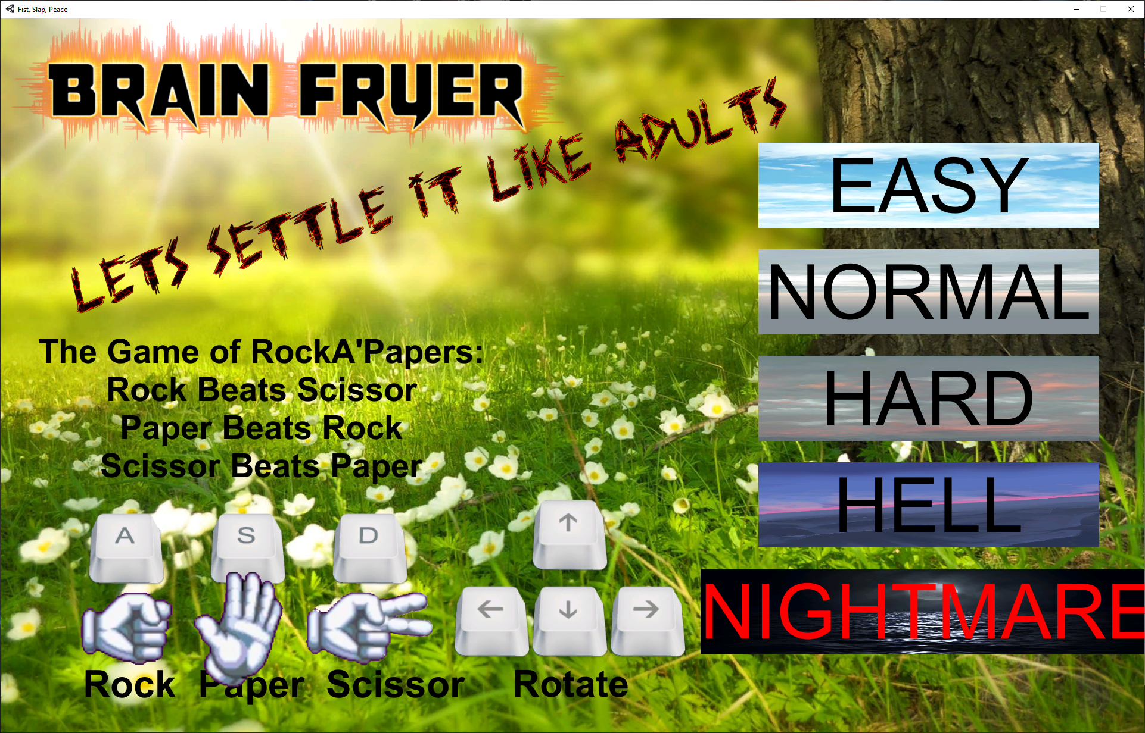

There space fillers like the title at the top left, and a standard Rock Paper Scissors motto along with the rules and controls at the bottom left.

On the right are buttons where players can select their desired level of difficulty.

## Game Play

Below is the breakdown of the gaming aspect.

## EASY MODE

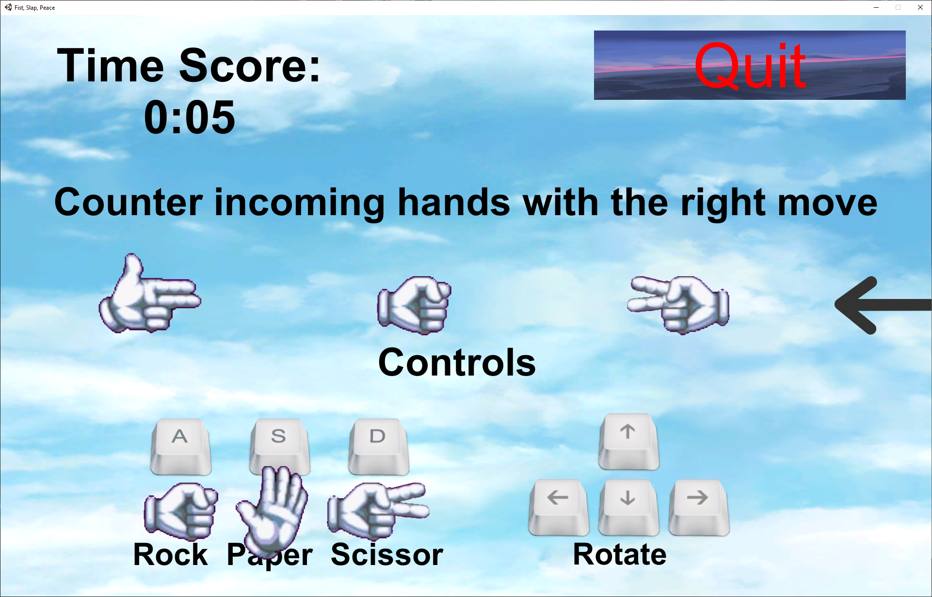

General Interface:

|  |  |
| --- | --- |
|  | Top Right contains the score tracker, where it will indicate how long the player has survived |
|  | The Quit Button will send the player straight to the GAME OVER page if they ever feel that they don’t want to wait to die or if they mis clicked a level. |
|  | (ONLY FOR EASY MODE)  At the far bottom we have the Controls Interface to allow new players to reference the controls and their corresponding projecting hands |
| Player’s Hand Projecting Hand after Shooting Incoming Generated Hand | |
|  | |

## Normal

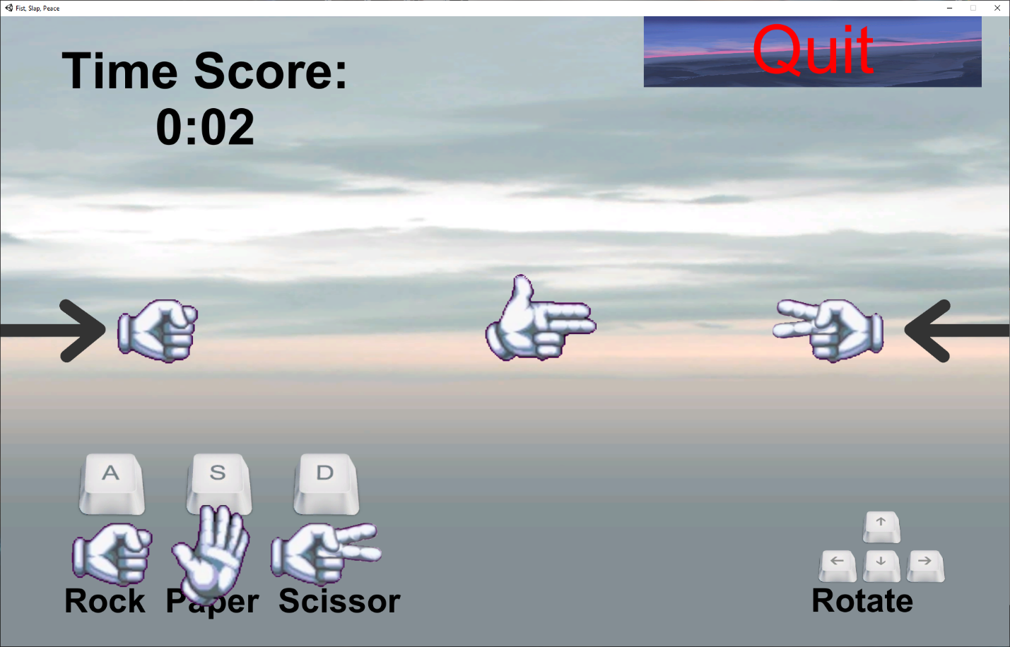

Changes:

|  |
| --- |
| Everything is similar to EASY Mode but hands come from an additional direction |
| Incoming Hand from Left Side Incoming Hand from Right Side |
| Player’s Hand |
|  |

## Hard Mode

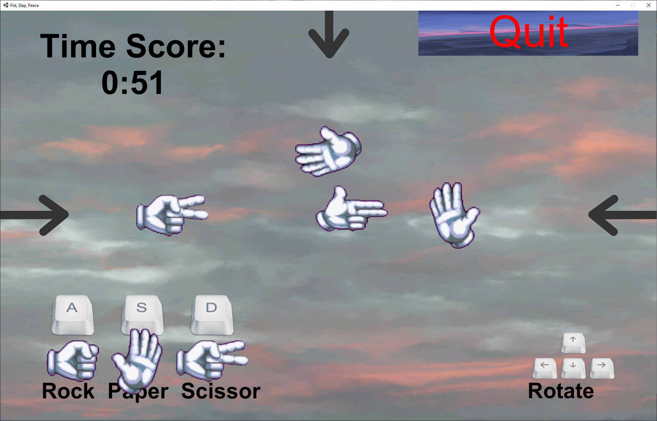

Changes:

|  |
| --- |
| Everything is similar to Normal Mode but hands come from an additional direction (Left, Right & Top) |
| Incoming Hand from Top Side |
| Incoming Hand from Left Side Incoming Hand from Right Side |
|  |
| Player’s Hand |

## Hell Mode

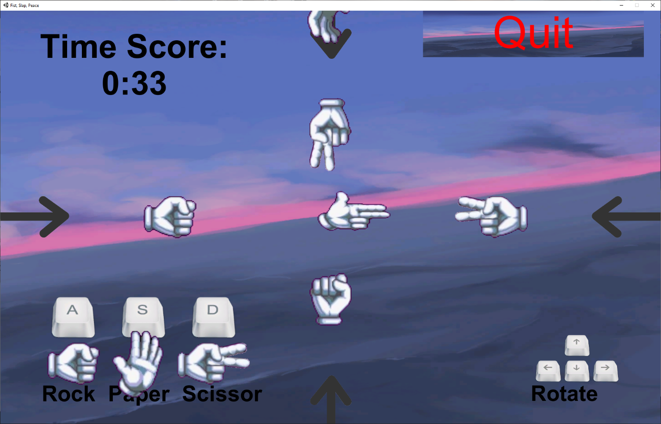

Changes:

|  |
| --- |
| Hands come from all four directions |
|  |

## Nightmare

**Same as HELL but incoming generated hands’ speed are increased**